Data Science Lab 5

Q1. Implement Linear Regression on the given Dataset from scratch without using any library, and compute coefficients, co-variance, standard deviation, and plot the results.

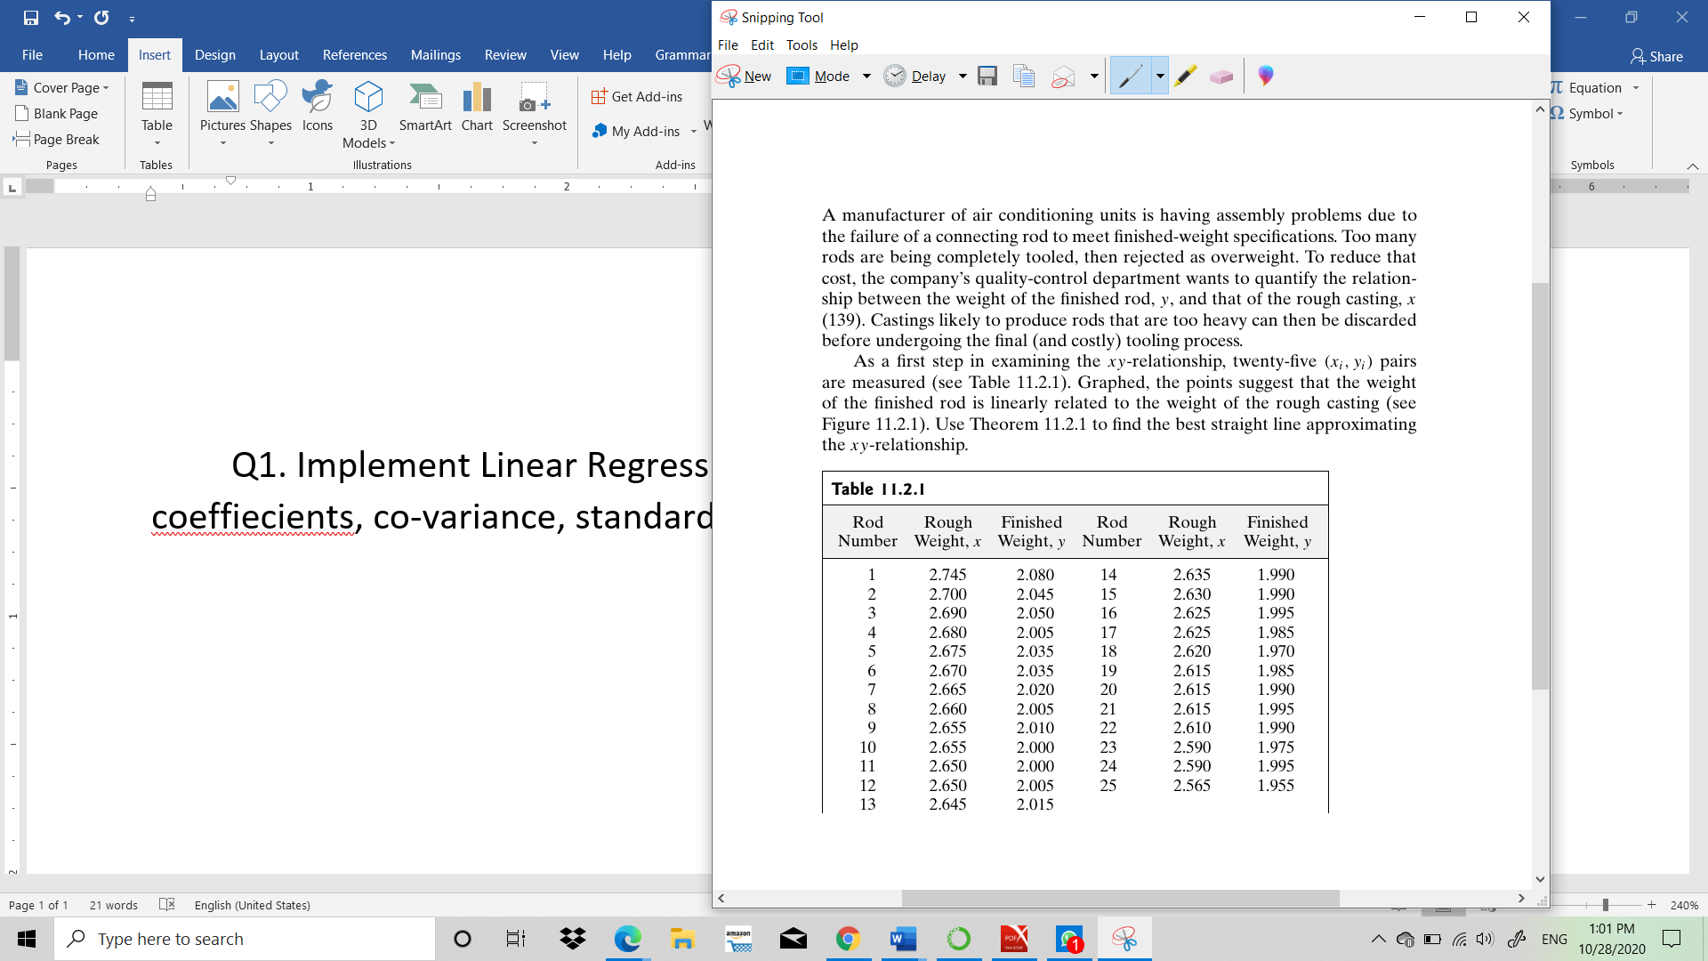

Q2. Plot the residuals for the dataset.

Q3. Implement polynomial regression and exponential regression model for the dataset.

b